**9**` 

Homeroom Guidance

**Quarter 1 – Module 4:**

**Becoming Better with Self-Discipline**



**Name:** Paul Gerald D. Pare

**Section:** 9 - Adenine

**Homeroom Guidance Self-learning Module – Grade 9** Quarter 1 Module 4: Becoming Better with Self-Discipline 2020 Edition

**The Intellectual Property Code of the Philippines** states that “No copyright shall subsist in any work of the Government of the Philippines. However, prior approval of the government agency or office wherein the work is created shall be necessary for exploitation of such work for profit. Such agency or office may, among other things, impose as a condition the payment of royalties.”

Borrowed materials (e.g., texts, illustrations, musical notations, photos, and other copyrightable, patentable contents) included in this learning resource are owned by their respective copyright and intellectual property right holders. Where applicable, DepEd has sought permission from these owners specifically for the development and printing of this learning resource. As such, using these materials in any form other than agreed framework requires another permission and/or licensing.

No part of this material, including its original and borrowed contents, may be reproduced in any form without written permission from the Department of Education.

**Recommended Entry for Citation Purposes:**

Department of Education. *Homeroom Guidance Grade 9 Self-learning Module 4: Becoming Better with Self-Discipline*. Manila: Department of Education Central Office, 2020.

Published by the Department of Education Secretary: Leonor Magtolis Briones Undersecretary: Diosdado M. San Antonio Assistant Secretary: Alma Ruby C. Torio

**Development Team**

**Writers:** Katherine Kris M. Sangalang, Crissa P. Zamoranos

**Grade Level Coordinator:** Melanie O. Mandin

**Editors:** Mark Anthony Bercando, Jona Kristen Valdez

**Layout Artists:** Jacqueline E.Libut and Cherry Amor R. Laroza

**Management Team:**

* Bureau of Curriculum Development: Jocelyn DR. Andaya,*Director IV,*Ma. Isabel Victorino, *CSDD Chief*, Mark Anthony Bercando,*Supervising EPS,*Jona Kristen Valdez, Melynda Andres, Senior EPS
* Bureau of Learning Resources

**Homeroom Guidance Grade 9 Quarter 1 – Module 4:**

**Becoming Better with Self-Discipline**

# Gabay sa Magulang/Tagapag-alaga

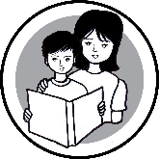

Isinulat ang modyul na ito upang higit na malinang, mapagtibay at mapalalim ng mag-aaral ang kaniyang disiplina at kontrol sa sarili sa tulong ng mga inihandang gawain. Ang isang kabataan na may maayos na disiplina at kontrol sa sarili ay mas madaling magkaroon ng pagkakakilanlan sa sarili. Higit sa lahat, mas madali siyang magiging kalmado lalo na sa gitna ng mga problema, tulad ng nangyayaring pandemya ngayon. Dinisenyo ito para sa *distance learning* o alternatibong pamamaraan ng pagkatuto na hindi nangangailangan ng pisikal na presensya sa paaralan, bilang tugon sa direktiba na pagkansela ng *face-to-face class* dulot ng pandemyang Covid-19.

Maaaring may mga pagkakataon na hihingiin ng mag-aaral ang inyong patnubay sa pagsunod sa mga tagubilin, pagsagot sa mga tanong sa bawat bahagi ng mga gawain at maging sa pagkakaroon ng mga kakailanganing materyales base sa nakatakdang gawain. Hinihiling ng Kagawaran ang inyong suporta upang matagumpay niyang maisakatuparan ang mga gawain. Makatutulong ang araling ito upang hubugin ang kaniyang kabutihan na tanggapin ang pagkakaiba-iba ng bawat tao sa katangian, kakayahan, damdamin at pananaw. Tiyakin na sasagutin niya ang bawat bahagi ng modyul nang tapat.

Kinakailangan din ang long folder na magsisilbing *portfolio* ng mag- aaral sa Homeroom Guidance. Dito isisilid lahat ng gawaing natapos sa bawat bahagi ng modyul. Tiyaking maipapasa ito sa petsa at oras na itinakda ng kanyang gurong-tagapayo.

# Introductory Message

### For the learner:

This module is designed to help you know more about self-discipline and how it helps you to develop a positive self-concept. There are activities that require a deeper look at yourself and will make you reflect on self-discipline practices in your decisions and actions.

This self-learning module has six indicative tasks, which are as follows:

 **Let’s Try This** –which will help you to get ready to learn;

**Let’s Explore This** – which will guide you towards what you need to learn;

**Keep in Mind** – which will give you the lessons that you need to learn and understand;

**You Can Do It** – which will help you apply the lessons learned in daily activities;

 **What I Have learned** – which will test and evaluate your learning;

**Share Your Thoughts and Feelings** – which will help you express your thoughts, opinions and feelings.

### Learn and be better! Enjoy your self-improvement process through this module.

|  |  |
| --- | --- |
| **MODULE**  **4** | **BECOMING BETTER WITH SELF-DISCIPLINE** |

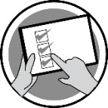**Learning Objectives**

At the end of this module, you are expected to:

1. explain the role of self-discipline in maintaining positive self-concept;
2. analyze how self-discipline reflects one’s action; and
3. narrate insights on applying self-discipline in facing personal changes.

**Period**: Week 4 of 1st Quarter

**Suggested Total Time Allotment**: 60 Minutes

#### Materials Needed:

* Clean sheets of paper/bond papers
* Pen/pencil
* Any coloring materials

**Introduction**

This module is intended to instill in you the importance of practicing self-discipline in everyday life. This is important as you stay strong and motivated in the midst

of the pandemic and as you begin to adapt to a new way of seeing things in this so-called new normal. Self-discipline is the ability to control one's feelings and overcome one's weaknesses. Self-discipline is also necessary for distance learning. Since the traditional ways of learning are temporarily suspended, you are committed to learn from home for now as effectively as possible, sometimes relying on the assistance that we get from our teachers, parents and the community in general. If you are the type of learner who normally needs to hear what you have to do, it is about time that you strengthen your self-discipline and become

focused and independent in no time.

In this module, you will exercise and test the discipline you have in yourself by not allowing external factors affect your focus and goal to complete your school tasks. You will also relate personal changes, problems, and situations that you encounter which require self- control in order to overcome the said challenges.

## Artboard 1@5xLet’s Review

In Module 3, you were able to know the different child rights, discussed how to exercise those rights responsibly, and realized your value as a member of your

family and community.

## A picture containing drawing Description automatically generatedLet’s Try This

**Suggested Time Allotment:** 10 minutes

Recall an experience when you were thankful for having controlled yourself from being impulsive. For example, when you avoided saying hurting words to a good friend or when you were able to save money by ignoring unnecessary things. After that moment, what were your thoughts and realizations about the incident? Capture your answers to the questions by making a simple poster. Use short bond paper, pencil and any coloring materials.

#### Processing Questions:

1. Did the experience change anything in you? Why or why not?
2. What could have happened if you were impulsive during that time?
3. What do you think will happen if you master to control your impulsive actions or behavior?

## A picture containing shape Description automatically generatedLet’s Explore This

**Suggested Time Allotment:** 10 minutes

#### Actions and their Consequences

Recall five actions that demonstrate your self-discipline and the results of these actions.

Write your answers using the table below. An example has been provided as your guide.

|  |  |  |
| --- | --- | --- |
| **Actions** |  | **Results or Effects** |
| Example: I logged out of my social media account to stay focus on my module. | Example: I was able to concentrate and understood easily the lessons in my  module. |
|  |  |
| 2. |  |
| 3. |  |
| 4. |  |
| 5. |  |

#### Processing Questions:

1. How do you feel about yourself upon seeing all your answers?
2. Are those actions helpful for you to have a positive image of yourself? How?
3. How should your self-discipline improve the way you see yourself?

## Icon Description automatically generatedKeep in Mind

**Suggested Time Allotment**: 15 minutes

Self-improvement does not only manifest in your physical look as it can also be seen in your behavior or command of emotions. Hence, when you develop self-discipline, you can see yourself regulating your emotions well and deciding carefully before taking actions. There’s nothing wrong if you feel different emotions such as being happy, angry, excited, sad, inspired, or disappointed, as those are normal reaction of any human being but the timing and the manner of expression make a difference. For instance, if you are angry, it is not an excuse to hurt other or break the things at home; or if you are happy, it is not enough reason to forget about your important and immediate tasks. There are proper ways and time to express those things and learning them means having self-discipline.

The following are just seven ways to increase self-discipline, as you can learn other things from other respected sources:

#### 7 Ways to Improve Self-Discipline

**C**ommit to your goal. Whether it’s getting over your emotions or getting enough sleep at night, it is important to go back to your goals; remind yourself why you need to do it and stick to it. **O**bjectivity is the key. Don’t be too hard on yourself but don’t be too easy as well. Put yourself in another perspective aside from yours so that you can look at a bigger picture of the situation. **N**ever underestimate willpower. Use your inner strength to resist temptations that will set you back from your goals.

**T**hink of your motivation. People have attested that constantly being presented with the reasons why they set their goals has an immense effect in helping them achieve what they want.

**R**est and reset. You don’t have to always outrun your goals. There are days when you walk on much slower pace and feel less motivated but use those days to help you power through and reach your goals.

**O**verwhelming yourself may not be okay. Don’t set too many unrealistic goals that you’ll have trouble finishing. It’s better to set one at a time than be overwhelmed with too many that you can no longer handle.

**L**ive a life with a can-do attitude. Believe in yourself and in your ability to attain whatever goal you want.

Self-discipline has been regarded as a staple key in achieving balance in one’s life. Now that we have been ushered into a new normal brought by the pandemic, the importance of having control in ourselves should be highlighted.

## A picture containing icon Description automatically generatedYou Can Do It

**Suggested Time Allotment:** 5 minutes

After learning how self-discipline plays an important role in the development of your positive self-concept, identify one behavior that you will try to do as your attempt to practice self-discipline. Complete the phrase below and write your answer on a sheet of paper.

#### From now on, I will try to…

 **What I have learned**

**Suggested Time Allotment**: 10 minutes

#### Thinking and Acting Ahead

* 1. Copy the table below on a clean sheet of paper/bond paper.
  2. Think of three situations that you can possibly encounter in life. Then think about what can go wrong in every situation you provided. Finally, write about possible preventions that you can do in order to avoid what can go wrong.



|  |  |  |
| --- | --- | --- |
| **Situation** | **What Can Go Wrong** | **Prevention** |
|  |  |  |
| 2. |  |  |
| 3. |  |  |

## A picture containing clock Description automatically generatedShare your Thoughts & Feelings

**Suggested Time Allotment**: 10 minutes

#### Letting Go

1. Draw six to eight balloons on a clean sheet of paper/bond paper.
2. Think carefully about the things about yourself that hold you back from exercising better self-discipline.
3. Close your eyes for a while and imagine letting go of your unhelpful behaviors, traits and practices.
4. Are you ready to let go? When you are, write the behaviors, traits and practices you have identified inside the balloon drawings which you think are not helping you exercise better self-discipline.

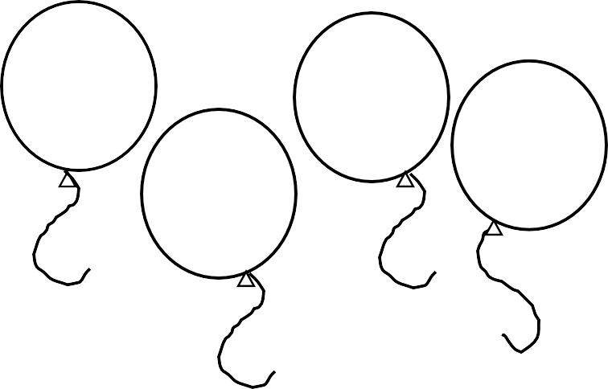

Skipping important events



**====================**

**For inquiries or feedback, please write or call:**

Department of Education - Bureau of Learning Resources (DepEd-BLR) Ground Floor, Bonifacio Bldg., DepEd Complex

Meralco Avenue, Pasig City, Philippines 1600 Telefax: (632) 8634-1072; 8634-1054; 8631-4985

Email Address: [blr.lrqad@deped.gov.ph](mailto:blr.lrqad@deped.gov.ph) * [blr.lrpd@deped.gov.ph](mailto:blr.lrpd@deped.gov.ph)